Luis Morales
CSCI 4321 - Computer Security
August 27, 2025
Lab 04 – Morris Worm

First we install docker:
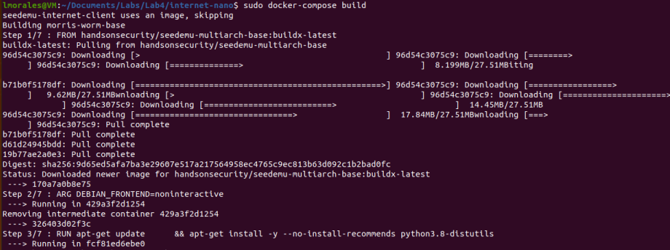
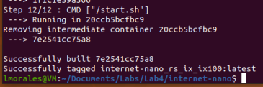

Then we start docker:
The first run failed using “docker-compose up” for insufficient permissions
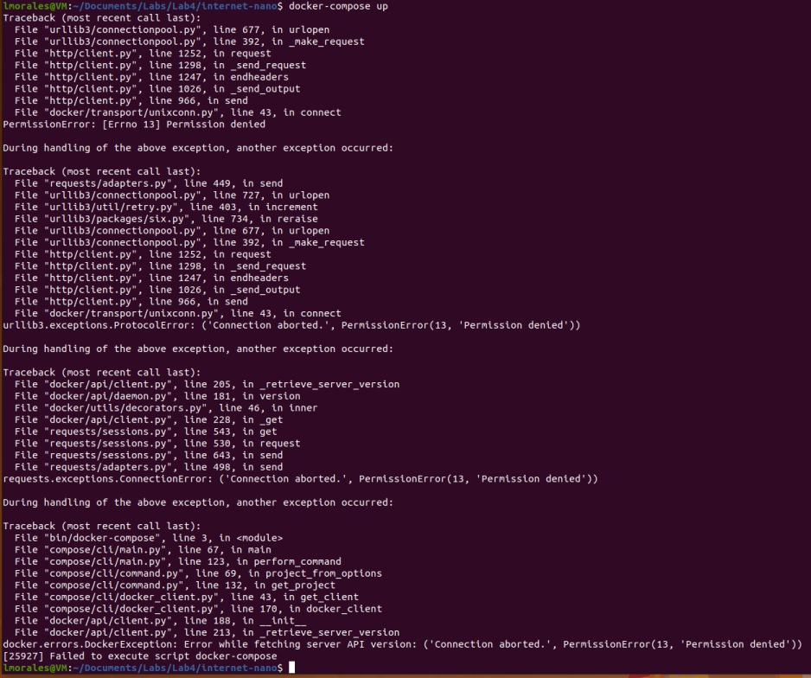

Tried again with sudo
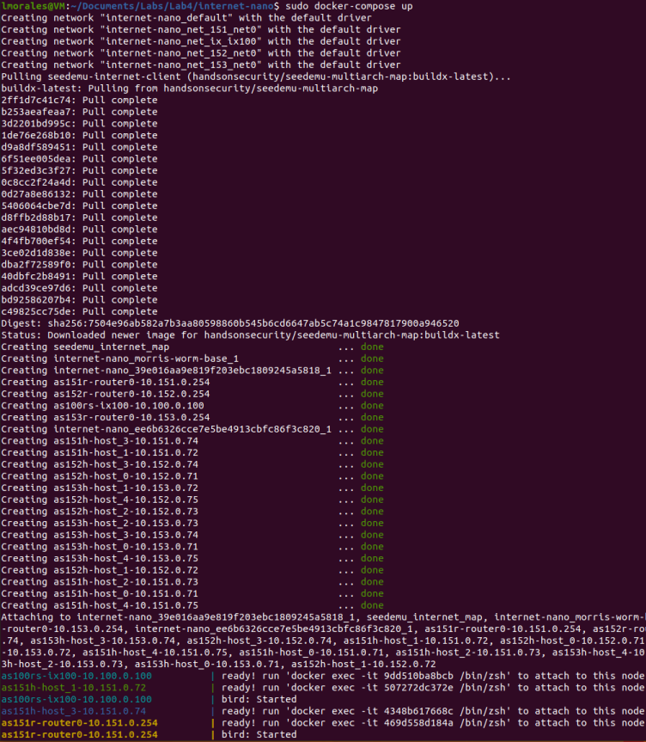
docker ps was used to get a list of running containers. I tried the dockps command in the sample document, but I guess the alias was on created in the vm (I will not be creating that alias). I went to the manual and found the original command: docker ps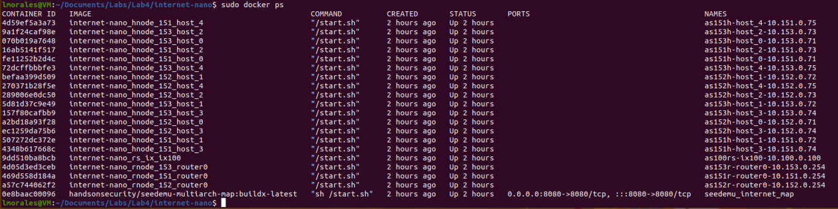

I then used the ping command:

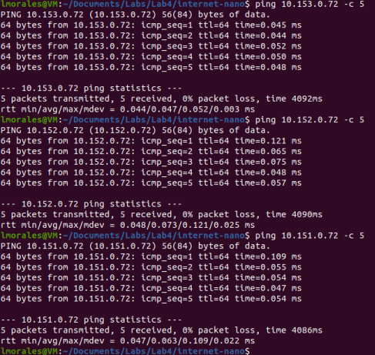
I also tried to ping using the container ID: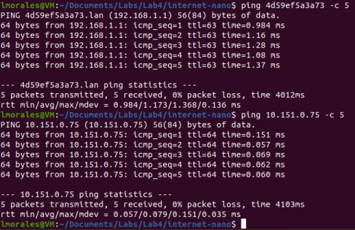
http://localhost:8080/map.html
This page was used to track network traffic. In this screenshot I created some traffic by using two terminals to ping two other terminals. 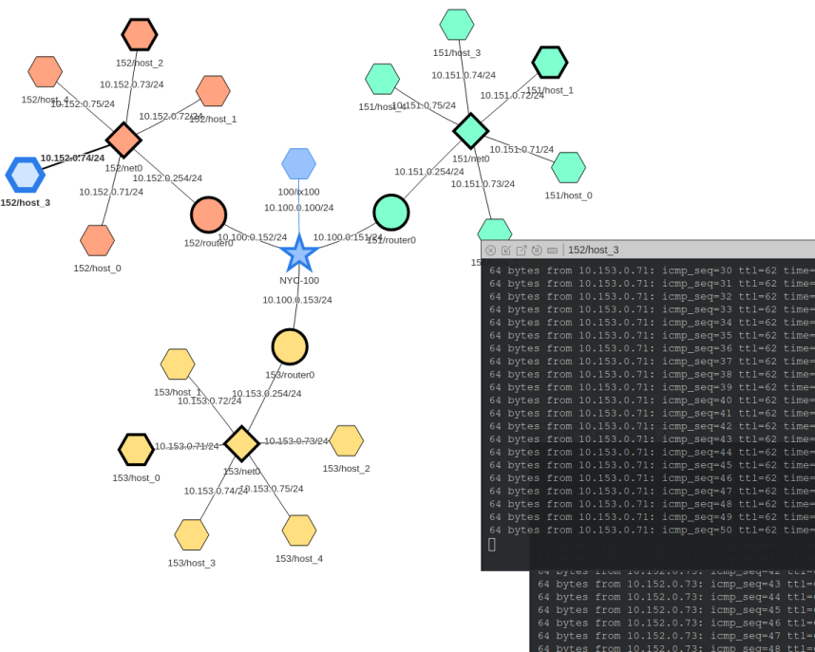

Once we saw that the hosts could talk to one another I started the attack:

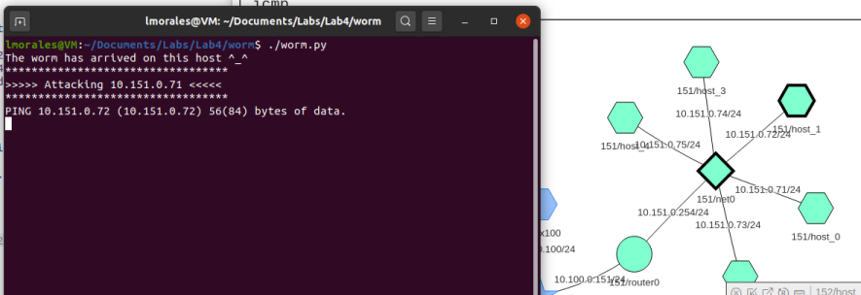
The activity can be monitored using the webpage generated for the network. In this image I’m using the “icmp” option.

Task 1 – Get Familiar with the Lab Setup

Infecting single host:
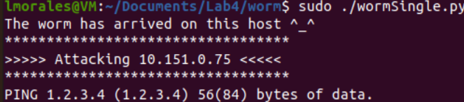

Infecting multiple hosts:
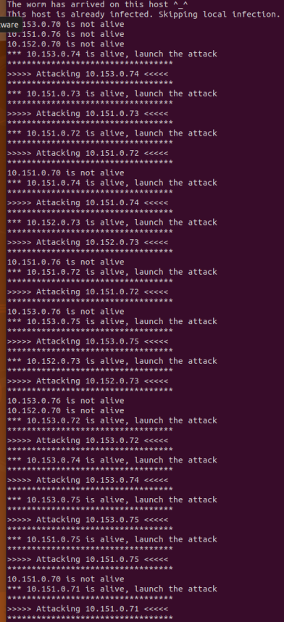
In the screenshot above you can see that the program checked to see if the host was alive before attacking.

This lab gave an interesting look at how worms self-replicate and spread through a network. Markers were a good way to let the virus know that a host had already been infected previously and to move on to the next target. It’s a bit scary thinking about just how susceptible vulnerabilities can make not only a host but an entire network.
I had never used docker before and was amazed at how and entire network or even an “internet” could be emulated on a single computer.

